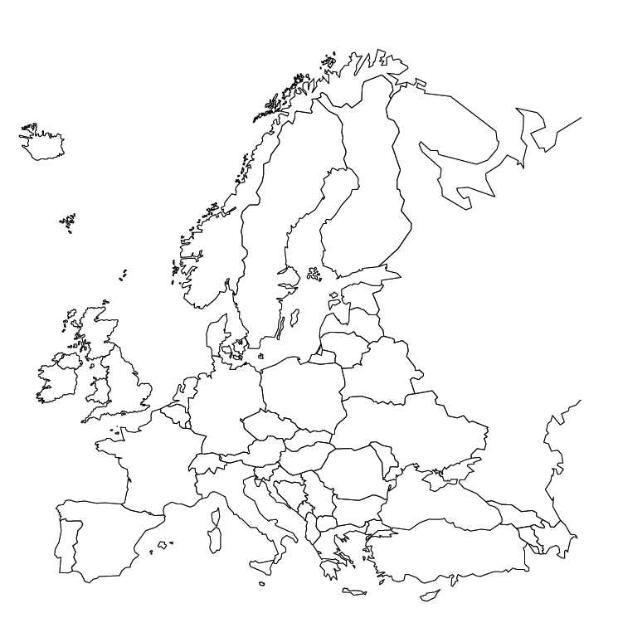

Sea/Ocean

Mountains

**Key**

Plains